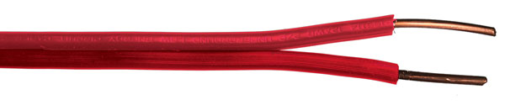**Decoder-to-Solenoid Cables –** These cables are required in order to facilitate the installation when using decoders with multiple outputs for solenoids.

**Paige Electric Co., LP specification number P7351D. No equal.**

The colors of the output wires of the decoder are as follows:

For TORO systems:

|  |  |  |  |  |  |
| --- | --- | --- | --- | --- | --- |
| TORO Models | No. of Outputs | **DTS Cable Color & Paige Electric Part Numbers** | | | |
| Red 170803RD | Blue 170803BU | Green 170803GN | Orange 170803OG |
| DEC-1 | 1 | X |  |  |  |
| DEC-2 | 2 |  |  | X | X |
| DEC-4 | 4 | X | X | X | X |

The contractor shall match the colors of the decoder output wires when the solenoid is not in the same valve box as the decoder. DTS cables shall be used for this purpose. Here is a typical installation of a system using decoders with 6 outputs:

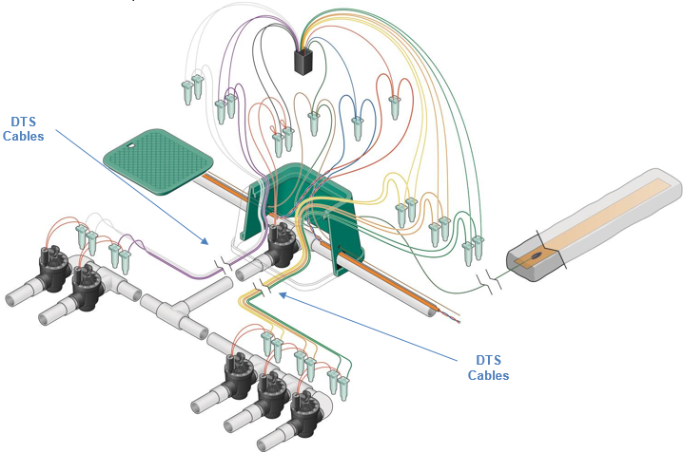

***Installation Tips of DTS Cables in TORO Systems:***

TORO Decoder Systems utilize “latching” solenoids. This means that the decoder sends temporary pulses to turn the solenoid ON (positive pulse) and OFF (negative pulse.) For this reason, the wiring must be polarized or the valve will go OFF when turned on and it will go ON when turned off.

The decoders have two output wires, one of a solid color and the other is the same solid color with a black stripe. The DTS cables have two zipped wires, one of a solid color and the other is the same solid color with black printing. Connect the decoder wire with the black stripe to the DTS wire with black printing. See photo below.

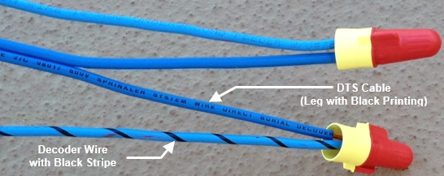

At the valve location, connect the DTS wire with black printing to the black solenoid wire.