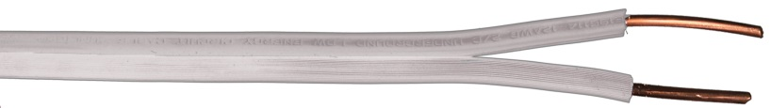**Decoder-to-Solenoid Cables –** These cables are required in order to facilitate the installation when using decoders with multiple outputs for solenoids.

**Paige Electric Co., LP specification number P7351D. No equal.**

The colors of the output wires of the decoder are as follows:

For Rain Bird systems:

|  |  |  |  |  |  |  |  |
| --- | --- | --- | --- | --- | --- | --- | --- |
| Rain Bird Model | No. of Outputs | **DTS Cable Color & Paige Electric Part Numbers** | | | | | |
| Red 170803RD | Brown 170803BN | Gray 170803GY | Orange 170803OG | Black 170803BK | White 170803WT |
| FD-101 | 1 |  |  |  |  |  | X |
| FD-102 |
| FD-202 | 2 |  | X |  |  |  | X |
| FD-401 | 4 | X | X |  | X | X |  |
| FD-601 | 6 | X | X | X | X | X | X |

The contractor shall match the colors of the decoder output wires when the solenoid is not in the same valve box as the decoder. DTS cables shall be used for this purpose. Here is a typical installation of a system using decoders with 6 outputs:

