**Decoder-to-Solenoid Cables –** These cables are required in order to facilitate the installation when using decoders with multiple outputs for solenoids.

**Paige Electric Co., LP specification number P7351D. No equal.**

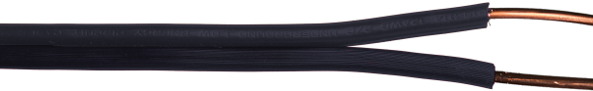

The colors of the output wires of the decoder are as follows:

For Hunter systems:

|  |  |  |  |  |  |  |  |
| --- | --- | --- | --- | --- | --- | --- | --- |
| Hunter Model | No of Outputs | **DTS Cable Color & Paige Electric Part Numbers** | | | | | |
| Green 170803GN | Orange 170803OG | Black 170803BK | Yellow 170803YL | White 170803WT | Purple 170803PR |
| ICD-100 | 1 |  |  | X |  |  |  |
| ICD-200 | 2 |  |  | X | X |  |  |
| ICD-300 | 4 | X |  | X | X | X |  |
| ICD-400 | 6 | X | X | X | X | X | X |

The contractor shall match the colors of the decoder output wires when the solenoid is not in the same valve box as the decoder. DTS cables shall be used for this purpose. Here is a typical installation of a system using decoders with 6 outputs:

