Installation Tips:

The removal of the outer jacket of decoder cables can cause tremendous problems if not done properly. If the insulation of the inner conductors is damaged with a knife or other tool, a short circuit will develop in the ground and cause severe problems. It is recommended that 12” of the outer jacket is removed so that the inner wires can be easily joined using waterproof connectors.

Here is the proper method for removing the outer jackets:

Jacketed Cables for Hunter Decoder Systems: The outer jacket of these Paige Electric decoder cables is a loose tube. This may not be so with other brands of cable. The loose tube design allows long lengths of the outer jacket to be snapped and removed cleanly. Here are the steps for removing the loose tube outer jacket:

Step 1 - Use a pocket or utility knife to radially score the outer jacket of the cable about 12” from the end.  DO NOT CUT ALL THE WAY THROUGH THE OUTER JACKET.  DO NOT CUT INTO THE INSULATION OF THE INNER WIRES. | 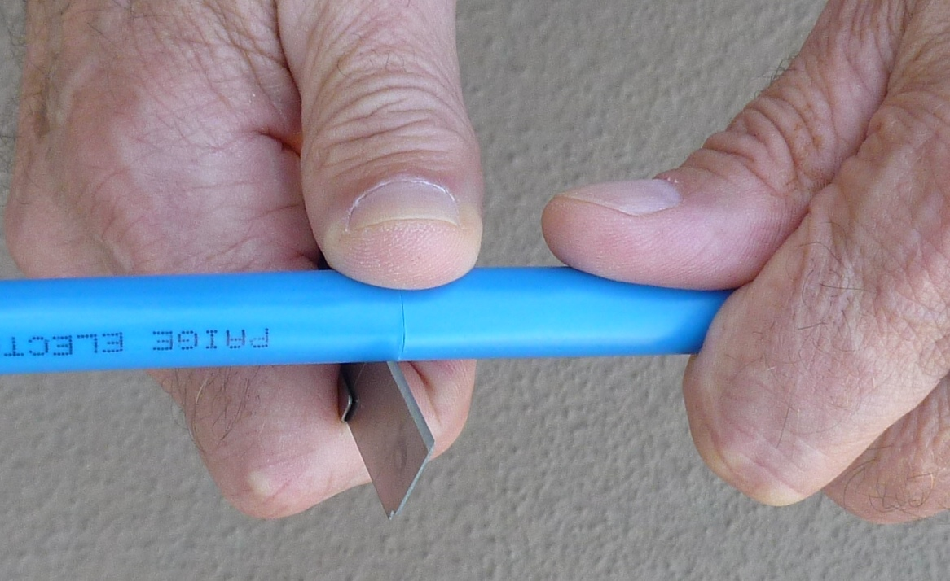
Step 2 - Bend the jacket back-and forth at the point where the jacket was scored with the knife. The jacket will snap. | 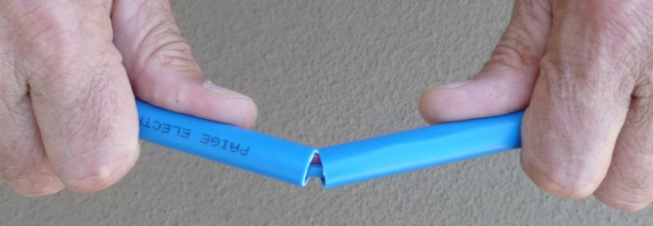  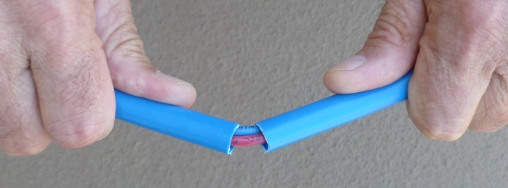
Step 3 - Now slide the 12” piece of jacket off to expose the twisted pair of wires.  Step 4 - Inspect the inner conductors to make sure there are no nicks or cuts in the wires. If nicks are found, cut the wires off at the nick point and start over. | 