**DECODER CABLES**

**Jacketed Cable for TORO and Irritrol Decoder Systems –** The decoder cable shall consist of 2 wires, twisted together. Its construction incorporates solid copper conductors with PE insulation with a minimum wall thickness of 0.045”. It shall incorporate an overall PE jacket with a thickness of 0.35”. The jacket shall have a minimum inner diameter of 0.358” for 14AWG/2c and 0.386” for 12AWG/2c so that it creates a loose tube for ease of removal of the outer jacket without damaging the inner conductors. The cable shall be 14AWG/2c unless otherwise called-for in the irrigation plans and specifications. The cable shall be listed for direct burial in irrigation systems.

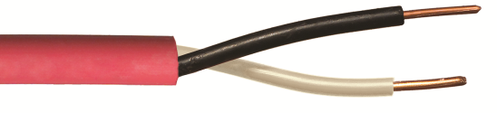

If a separate outer jacket color is required for each zone and the plans don’t specify colors, choose from the following list: Red, Black, Yellow, Green, Blue, Orange, Purple, Tan or Gray.

**Paige Electric Co., LP specification number P7350D. No equal.**