**DECODER CABLES**

**For Rain Bird Decoder Systems –** The decoder cable shall be 14AWG/2c or 12AWG/2c “Maxi”, as shown on the irrigation plans. The cable shall include two type UF/TWU wires with a PE outer jacket. The cable shall be 14AWG/2c unless otherwise called-for in the irrigation plans and specifications. The inner conductors shall be listed for direct burial.

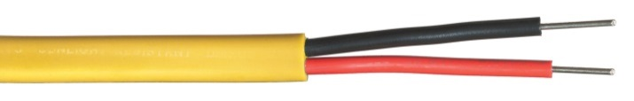

If a separate outer jacket color is required for each zone and the plans don’t specify colors, choose from the following list: Blue, Green, Red, Yellow, Black, Orange, Purple, White, Tan, Brown, Gray or Pink

**Paige Electric Co., LP specification number P7072D. No equal.**