**CENTRAL-SATELLITE COMMUNICATION CABLES**

No Communication Cable underground splices are allowed unless it is necessary to make a repair. All repair splices shall be inside valve boxes and noted on the as-built.

**Shielded and Armored Cable for TORO Systems -** The communication cable shall be 16 AWG/1-pair. The construction shall include stranded tin coated copper conductors, an aluminum shield to prevent interference due to electro-magnetic noise, a solid tin coated drain wire for grounding the cable, a stainless steel tape helically wrapped around the pair of wires (for rodent protection), and an overall PE jacket. The cable shall be listed for direct burial.

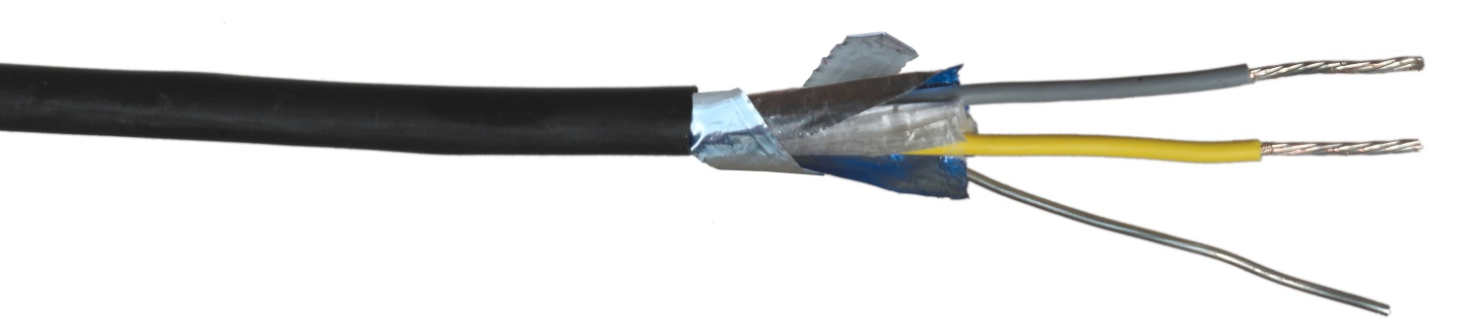**Paige Electric Co., LP specification number P7162D-A, or approved equal.**