**CENTRAL-SATELLITE COMMUNICATION CABLES**

No Communication Cable underground splices are allowed unless it is necessary to make a repair. All repair splices shall be inside valve boxes and noted on the as-built.

**Cable for Rain Bird “Maxi” Systems -** The communication cable for “Maxi” systems shall be 14AWG/2c and/or 12AWG/2c, as shown on the irrigation plans. The cable shall include two type UF/TWU wires with a PE outer jacket. The cable shall be 14AWG/2c unless otherwise called-for in the irrigation plans and specifications. The inner conductors shall be listed for direct burial.

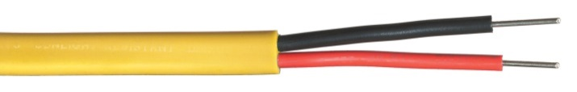

If a separate outer jacket color is required for each zone and the plans don’t specify colors, choose from the following list: Blue, Green, Red, Yellow, Black, Orange, Purple, White, Tan, Brown, Gray or Pink  
**Paige Electric Co., LP specification number P7072D. No equal.**

`