**CENTRAL-SATELLITE COMMUNICATION CABLES**

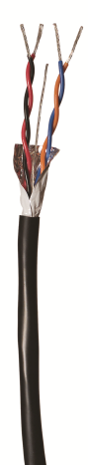No Communication Cable underground splices are allowed unless it is necessary to make a repair. All repair splices shall be inside valve boxes and noted on the as-built.

**Shielded Cable for Hunter Systems –** The communication cable shall be 18AWG/2-pair. The construction shall include stranded tin coated copper conductors, an aluminum shield to prevent interference due to electro-magnetic noise, a 20AWG tin coated copper drain wire for grounding the cable, and an overall PE jacket. The cable shall be listed for direct burial.   
**Paige Electric Co., LP specification number P7171D, or approved equal.**