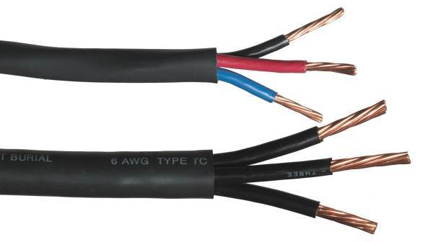

**Type Tray Cable –** All branch circuit power cables shall be type Tray Cable. They are to be listed for direct burial, and rated at 600 volts. The cable shall include “three conductors” (for 120 or 240 volt circuits.) The inner conductors of the cables are colored (blue, red and black) for cables of 10AWG and smaller. For cables of 8AWG and larger, the inner conductors are all black, but numbered (1, 2, and 3).

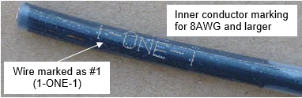

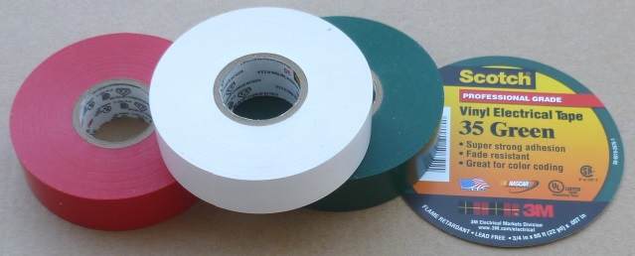

The full length of the exposed inner conductors shall be color-coded at every splice and termination (using 3M #35 Vinyl Electrical Color Coding Tape) to National Electrical Code® and electrical industry standards, as per the charts below:

For sizes of 10AWG and smaller the inner conductor colors are usually black, red, and blue. Color coding shall be as follows (note that color coding is different for 120-volt and 240-volt systems):

|  |  |  |
| --- | --- | --- |
|  | **Branch Circuit** | |
| **Conductor Color** | **120-volt** | **240-volt** |
| **Tape Color** | |
| Black | None | None |
| Red | White | None |
| Blue | Green | Green |

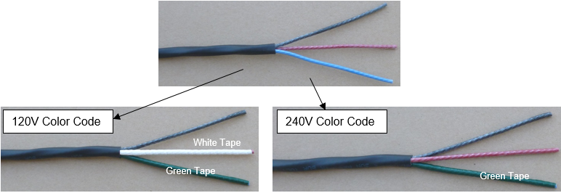

The inner conductors of Tray Cable of sizes 8AWG, and larger, are usually black and numbered 1, 2, and 3. These must be color coded as follows:

|  |  |  |
| --- | --- | --- |
|  | **Branch Circuit** | |
| **Conductor Color** | **120-volt** | **240-volt** |
| **Tape Color** | |
| Black (1) | None | None |
| Black (2) | White | Red |
| Black (3) | Green | Green |

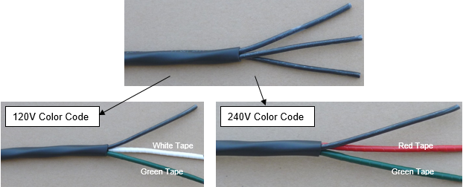

Wire sizes are defined in the irrigation plans and other specifications.

**Paige Electric Co., LP specification number P7266D (for 10AWG and smaller) or specification number P7267D (for 8AWG and larger), or approved equal.**