**POWER WIRES AND CABLES**

**Single Conductors, Type THWN, installed in electrical conduit –** All branch circuit wires shall be type THWN and sized according to the irrigation system plans. They are to be listed for wet and damp locations, installed inside electrical conduit, and rated at 600 volts.

The copper conductors shall be insulated with PVC/Nylon and colored as follows:

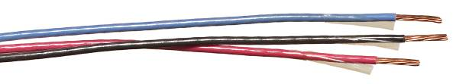

|  |  |  |  |  |
| --- | --- | --- | --- | --- |
| **120-volt system** | |  | **240-volt system** | |
| Hot | Black |  | Hot (Line 1) | Black |
| Neutral | White |  | Hot (Line 2) | Red |
| Equipment ground | Green |  | Equipment ground | Green |

**Paige Electric Co., LP specification number P7316D, or approved equal.**