**POWER WIRES AND CABLES**

**Single Conductors, Type UF/TWU, direct burial –** All branch circuit wires shall be type UF and sized according to the irrigation system plans. They are to be listed for direct burial, and rated at 600 volts. The copper conductors shall be insulated with PVC and colored as follows:

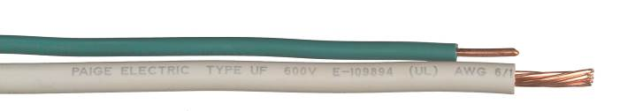

|  |  |
| --- | --- |
| **120-volt system** | |
| Hot | Black |
| Neutral | White |
| Equipment ground | Green |

|  |  |
| --- | --- |
| **240-volt system** | |
| Hot (Line 1) | Black |
| Hot (Line 2) | Red |
| Equipment ground | Green |

**Paige Electric Co., LP specification number P7001D, or approved equal**.