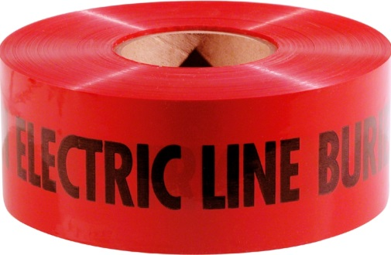**WARNING TAPE**

A 3” wide warning Tape shall be installed above all electrical wires and cables at a depth of 9” to 12”.

**Paige Electric part number 270328. No equal.**