**WIRE MARKING TAGS**

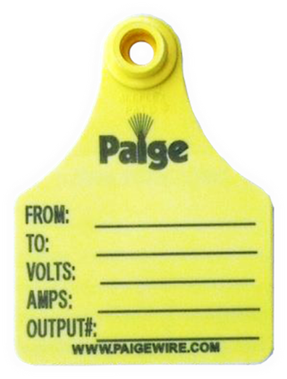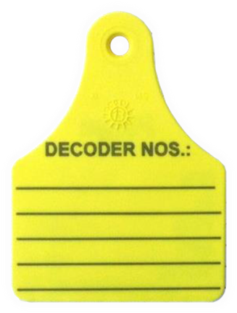

In order to facilitate troubleshooting of the irrigation systems, the installer shall place Wire Marking Tags at the locations detailed below. The information written on the Wire Marking Tags has to be done with a compatible Wire Marking Pen; otherwise the ink will fade or wash-off.

**Paige Electric part number 270WMT. No equal.**

**Paige Electric part number 270WMP. No equal.**

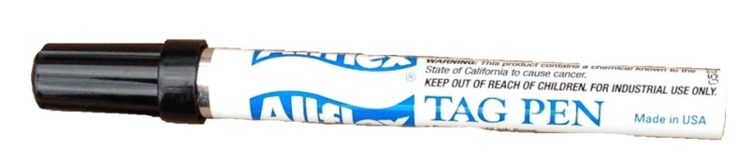

**Here is the typical information required on the Marking Tags**:

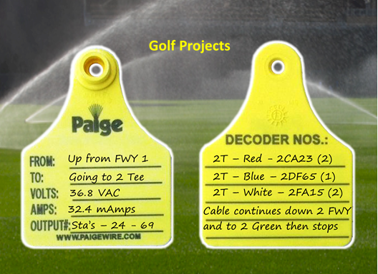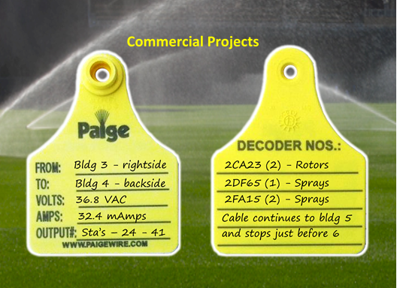

**Where to install Wire Marking Tags -** Generally speaking, Wire marking tags are to be installed at each valve box and each wire termination. Here are more specific details on where to install wire tags and the information needed (in parenthesis):

For Conventional/Satellite Systems

1. Power Wires & Cables
   1. At each power source. If more than one power source is used for the irrigations system, then write the power source number on the back of the tag (example: Power Source #2)
   2. Inside each controller.
      1. Incoming cable (FROM, VOLTS, AMPS)
      2. Outgoing cable(s) to the next controller(s) (TO, VOLTS, AMPS)
   3. At every underground junction/splice, which should be housed in a valve box
      1. Incoming cable (FROM, VOLTS, AMPS)
      2. Outgoing cables (TO, VOLTS, AMPS)
2. Communication Cables from Central location to satellite controllers
   1. At the central computer (TO, Notes on the back of the tag)
   2. Inside each controller
      1. Incoming cable (FROM, Notes on back of tag)
      2. Outgoing cable(s) to the next controller(s) (TO, Notes on back of tag)
3. At every underground junction/splice, which should be made only for repairs of damaged cables, and should be housed inside a valve box
   * 1. Incoming cable (FROM, Notes on back of tag)
     2. Outgoing cable to the next controller (TO, Notes on back of tag)

For 2-Wire Systems (Decoder or Integrated Devices)

1. At each cable exiting the central computer/interface location (TO, VOLTS, AMPS)
2. At each Decoder/Integrated Device
   1. Incoming cable (FROM, VOLTS, AMPS)
   2. Outgoing cable to the next Decoder/Integrated Device (TO, VOLTS, AMPS)
3. Decoder Cable Fuse Devices. Measurements can be made by unscrewing the cap and touching the test points with a multi-meter
   1. Incoming cable (FROM, VOLTS, AMPS)
   2. Outgoing cable to the next Decoder/Integrated Device (TO, VOLTS, AMPS, OUTPUT# 1, or 2, or 3)
4. External Lightning Arresters
   1. Incoming cable (FROM, VOLTS, AMPS)
   2. Outgoing cable to the next Decoder/Integrated Device (TO, Notes on back of tag)