**Decoder Cable Fuse Devices**

In order to facilitate troubleshooting of 2-Wire systems, Decoder Cable Fuse Devices (DCFD) shall be installed in strategic locations of the wiring network. These devices are similar to isolation valves in a piping system.

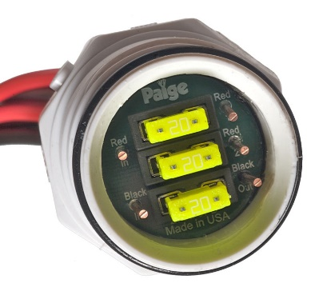This will allow the irrigation technician to quickly isolate sections of cable and groups of decoders without undoing splices. Just pull out a fuse to disconnect a leg of the electrical circuit.

The Decoder Cable Fuse Devices shall be located at all points of the electrical circuits where the cable splits in different directions.

The “Inline” model shall also be installed in all long/straight sections of cable of 500 feet or 10 decoders. The maximum spacing shall be 500’.

**Paige Electric part number 270DCFD1 (Inline)**

**Paige Electric part number 270DCFD (2-way split)**

**Paige Electric part number 270DCFD3 (3-way split)**

Typical installation for Decoder Cable Fuse Devices:



Internal Wiring Diagrams of the Decoder Cable Fuse Devices:

|  |  |  |
| --- | --- | --- |
| 270DCFD1 | 270DCFD | 270DCFD3 |

Typical installation for Decoder Cable Fuse Devices:

