**LIGHTNING AND SURGE PROTECTION FOR 2-WIRE SYSTEMS**

**Grounding and Bonding Decoder Systems -** It is the responsibility of the installer to connect the appropriate decoders to earth ground as shown in the details below. When installing the decoder cable, a loop of cable must be created so that it extends 36” from the top of the valve box. The loop can then be cut in order to make the wire connections. This loop is required for ease of installation and for future maintenance of the system.

The grounding/bonding components of the decoder system must be installed with the dimensional relationships shown in the details below. Wires, cables, and electronic equipment must be installed **outside** “the sphere of influence” of the grounding electrodes (green shaded area surrounding the ground plate in the details below.)

For Hunter: The colors of the conductors of the cable should be red and blue. The decoder has a red and a blue wire that should be connected to the cable, blue to blue and red to red.

For Rain Bird: The colors of the inner conductors of the cable should be red and black. The decoder has two light blue wires that should be connected to the red and black wires of the cable, either way.

For TORO: The colors of the conductors of the cable should be black and white. The decoder has a black and a white wire that should be connected to the cable, black to black and white to white.

Here is a typical generic illustration for the installation of a decoder, including the grounding/bonding grid:

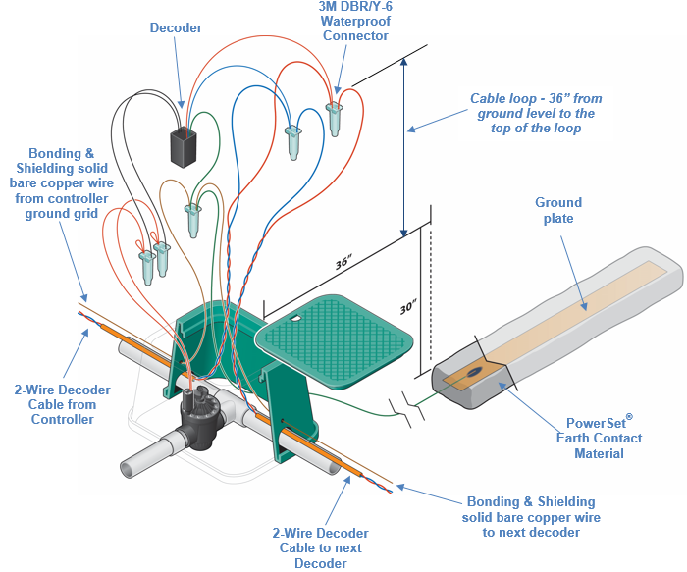

Grounding Decoders that have ground wires (some are bare copper and some have green insulated wires) – The Decoder ground wire must be connected to a ground plate as shown in the detail below or to a “bonding” wire that runs to the ground grids. The bonding wire is necessary to protect the 2-Wire cables and decoders from lightning and electrical surges

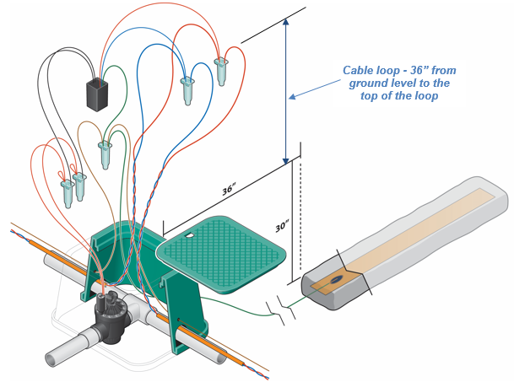

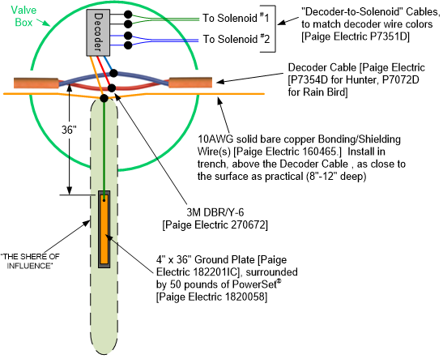  
Connecting/bonding Decoders that have ground wires that are not connected to a ground grid -The ground wire(s) of a decoder must be connected to bonding wires as shown in the detail below. The bonding wire is necessary to connect the decoder to adjacent ground grids.

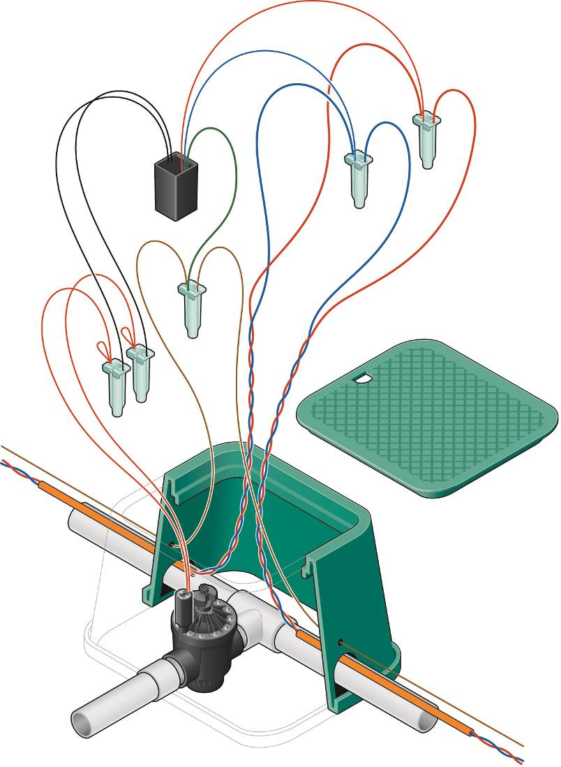

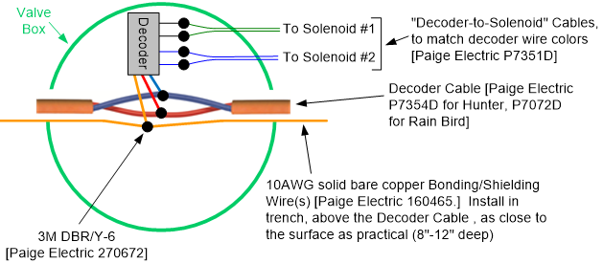

Electrical circuit for a zone utilizing decoders that have a ground wire on them:

**NO DECODER SHOULD BE MORE THAN 500 FEET (of wire path) AWAY FROM A GROUND GRID**

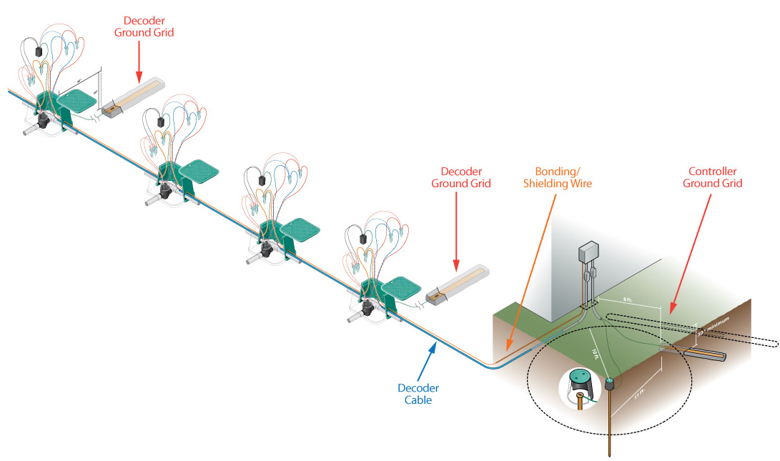

Electrical circuit for a zone utilizing decoders that don’t have a ground wire on them:

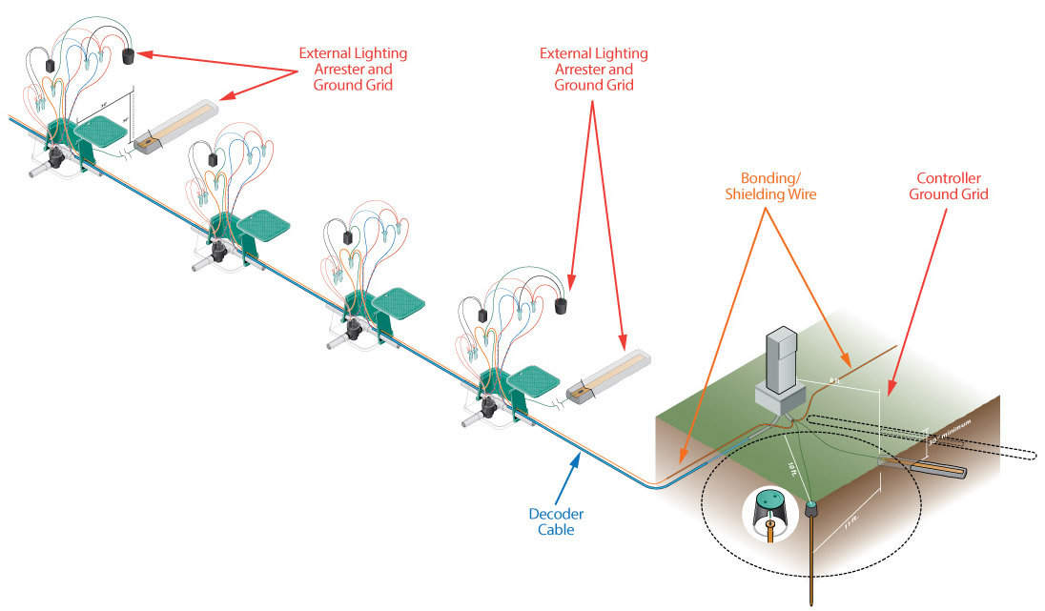

Grounding Decoders that don’t have ground wires – For systems that utilize Decoders that don’t have a ground wire, external lightning arresters must be used as recommended by the decoder manufacturer. The spacing of the lightning arresters/ground plates is as recommended by the decoder manufacturer, but, generally speaking, no decoder should be more than 500 feet (of cable) away from a lightning arrester/ground grid.

The ground wire of the lightning arrester must be connected to a ground plate as shown in the details below. A bonding wire must be connected from this grounded lightning arrester to the ground grid of the other lightning arresters in this zone/circuit, and also to the ground grid of the irrigation controller.

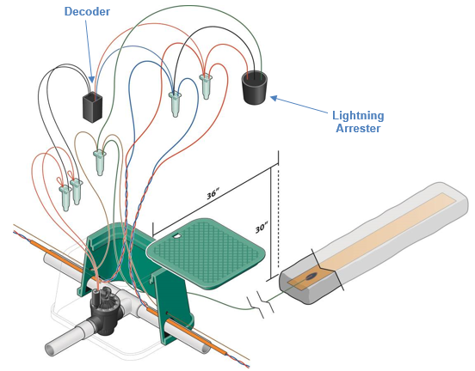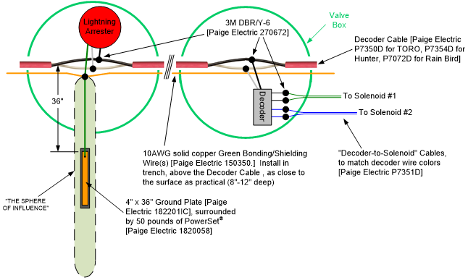

The ground grid components of the decoder system must be installed with the dimensional relationships shown in the details above. Wires, cables, and electronic equipment must be installed **outside** “THE SPHERE OF INFLUENCE” (green shaded area) of the grounding electrodes. See details above.

The copper ground plate assemblies must have minimum dimensions of 4” x 36” x 0.0625”. The plate shall incorporate a pre-welded 10AWG green-insulated wire with yellow stripe (about 25 feet long). This wire shall be connected to the decoder ground wires, lightning arrester wires and bonding wires.

The ground plate is to be installed to a minimum depth of 30”, or below the frost line if it is lower than 30”, at a location 36 inches from the cables and decoders.   
**Paige Electric part number 182201IC, no equal.**

A 50-pound bag of PowerSet® Earth Contact Material must be spread so that it surrounds the copper plate evenly along its length within a 6” wide trench. Pour ½ of the bag of the Earth Contact Material into the trench and rake to a uniform thickness. Place the ground plate above the Earth Contact Material and then pour the other ½ bag of the Earth Contact Material on top of the ground plate. The Earth Contact Material must cover all bear copper surfaces.

**Paige Electric part number 1820058, no equal.**

Salts, fertilizers, bentonite clay, cement, coke, carbon, and other chemicals are not to be used to improve soil conductivity because these materials are corrosive and will cause the copper electrodes to erode and become less effective with time.

Install all grounding and bonding wires in straight lines if possible. When necessary to make bends, make sweeping turns.

All underground connections of the grounding/bonding system are to be made by either:

* Using an exothermic welding process by utilizing the “Cadweld-Plus One-Shot” kits. Solder shall not be used to make connections.
* The 3M DBR/Y-6 waterproof connector

**Paige Electric part numbers 18200xxP for One-Shot kits**

**Paige Electric part number 1820040CU for Battery Control Unit**

**Paige Electric part numbers 270672 for 3M DBR/Y-6, no equal**

