**CONTROLLER LIGHTNING AND SURGE PROTECTION**



**Grounding Controllers -** It is the responsibility of the installer to connect all irrigation controllers to earth ground in accordance with Article 250 of the National Electrical Code® (NEC®.) Use grounding electrodes that are UL® listed or manufactured to meet the minimum requirements of the NEC®. At the very minimum, the grounding circuit will include a copper clad steel ground rod, a solid copper ground plate and 100 pounds of PowerSet® Earth Contact Material, as defined in these details.

The ground grid components must be installed with the dimensional relationships shown in these details. Wires, cables, and electronic equipment must be installed **outside** “THE SPHERE OF INFLUENCE” (green shaded area) of the grounding electrodes.



Typical Controller Ground Grid, Pedestal Mount:

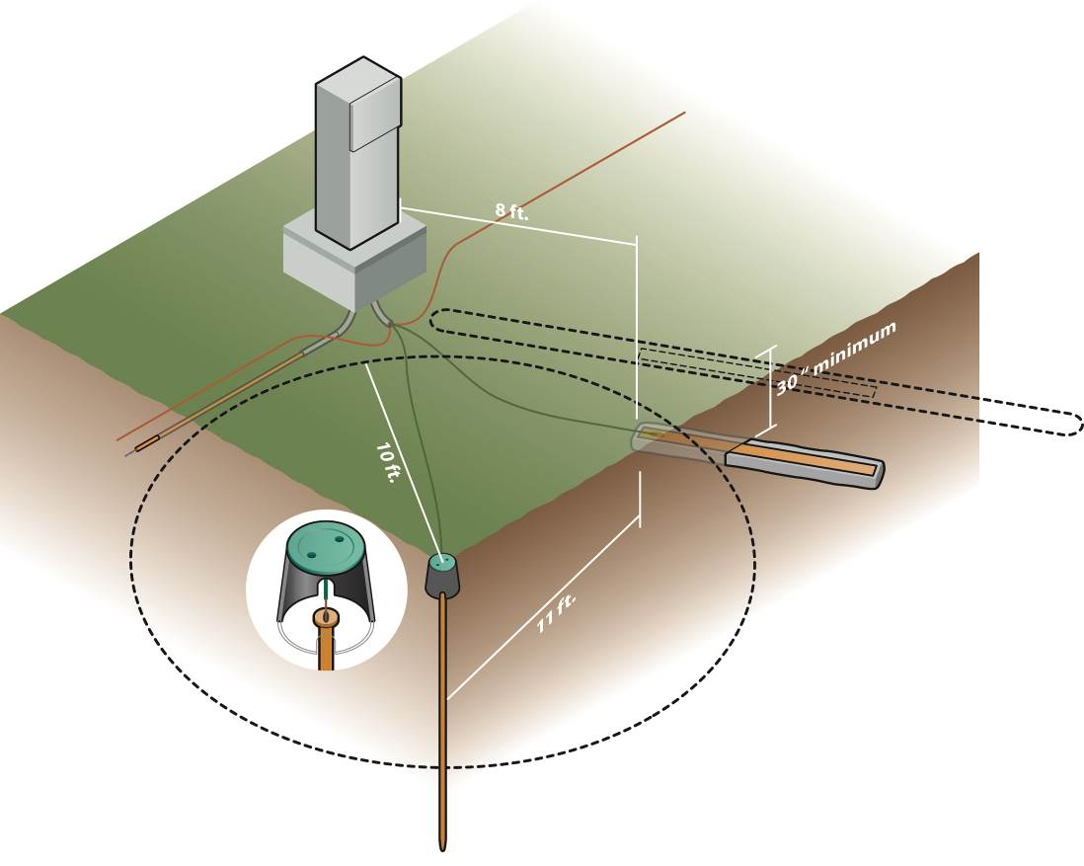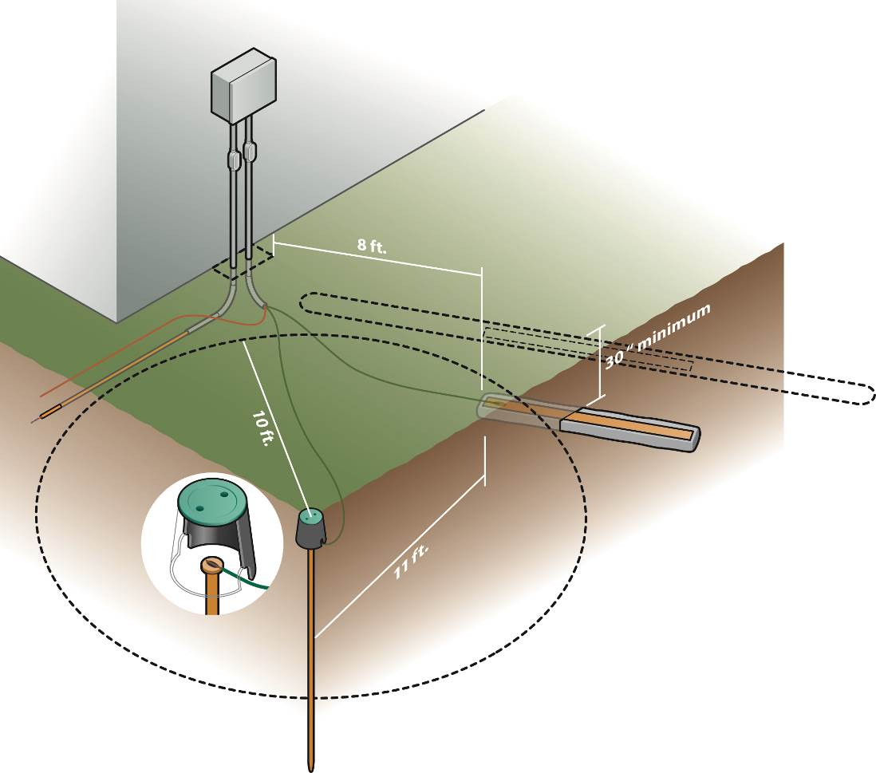

Typical Controller Ground Grid, Wall Mount:

Ground rods are to be driven into the ground in a vertical position or an oblique angle not to exceed 45 degrees at a location 10 feet from the electronic equipment. The rod is to be stamped with the UL® logo and shall have a pre-welded 6AWG green-insulated wire (about 25 feet long.) This wire shall be connected to the irrigation controller ground lug. A round valve box shall be installed as shown in the detail for accessing the ground rod.  
**Paige Electric part number 182007IC6. No equal.**

The copper grounding plate assemblies must have minimum dimensions of 4” x 8’ x 0.0625”. The plate shall incorporate a pre-welded 6AWG green-insulated wire with yellow stripe (about 25 feet long). This wire shall be connected to the irrigation controller ground lug.  
**Paige Electric part number 182199IC. No equal.**

The ground plate is to be installed to a minimum depth of 30”, or below the frost line if it is lower than 30”, at a location 8 feet from the electronic equipment and underground wires and cables.

Two 50-pound bags of PowerSet® Earth Contact Material must be spread so that it surrounds the copper plate evenly along its length within a 6” wide trench. Pour one bag of the earth contact material into the trench and rake to a uniform thickness. Place the ground plate above the Earth Contact Material and then pour the other bag of Earth Contact Material on top of the ground plate. The Earth Contact Material must cover all bear copper surfaces.

**Paige Electric part number 1820058. No equal.**

Salts, fertilizers, bentonite clay, cement, coke, carbon, and other chemicals are not to be used to improve soil conductivity because these materials are corrosive and will cause the copper electrodes to erode and become less effective with time.



Install all grounding and bonding wires in straight lines. When necessary to make bends, make sweeping turns. When connecting the ground rod and ground plate wires to the ground lug of the irrigation controller, feed it through a dedicated 1.5” plastic sweep ell. This will ensure the "sweep bends” comply with electrical code requirements, as shown here.

The earth-to-ground resistance of this circuit is to be measured using a Megger®, or other similar instrument, and the reading is to be no more than 10 Ohms. If the resistance is more than 10 ohms, additional ground plates and PowerSet® are to be installed. It is required that the soil surrounding copper electrodes within the “Sphere of Influence” (see green shaded area in the details above) be kept at a minimum moisture level of 15% at all times.

All underground connections are to be made using an exothermic welding process by utilizing the “Cadweld-Plus One-Shot” kits. Solder shall not be used to make connections. Mechanical clamps shall be permitted temporarily during the resistance test process, but are to be replaced with “Cadweld-Plus One-Shot” kits immediately thereafter. In order to ensure proper ignition of the “One-Shot”, the Cadweld Battery Control Unit must be utilized.

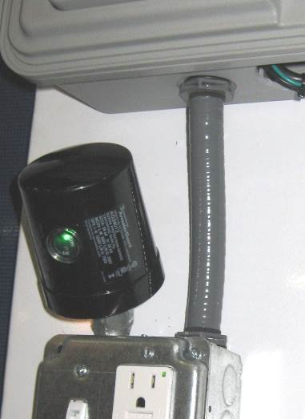**Paige Electric part numbers 18200xxP for One-Shot kits. No equal.**

**Paige Electric part number 1820040CU for Battery Control Unit. No equal.**

**Lightning arrester for the irrigation controllers**

The contractor is responsible for installing a lightning arrester on the incoming 120/240VAC wires to the controller, unless such lightning arrester is included by the controller manufacturer. The lightning arrester shall include a green LED indicator to show when the arrester is ready to suppress lightning surges. See photo for typical installation.

**Paige Electric part number 250090LED. No equal.Bonding Controllers**

The above grounding circuit is referred-to as “supplementary grounding" in the NEC®. And for safety reasons, the NEC® requires that all supplementary grounds be "bonded" to each other and to the ground grid at the service entrance (power source), as shown below. This bonding technique drastically reduces lightning damage to controllers by keeping all ground grid locations at nearly the same voltage during a storm.

120VAC Systems Wiring Schematic:



240VAC Systems Wiring Schematic:



The NEC® requires that the three power wires (Black, White and Green for 120VAC systems or Black, Red and Green for 240VAC systems) must always be kept together in a trench/conduit/tray/etc.

The bonding conductors are to be 6AWG solid bare copper unless the system power conductors are larger than 1/0AWG, in which case they are to be 4AWG solid bare copper. All underground bonding wire connections are to be made using an exothermic welding process by utilizing the “Cadweld-Plus One-Shot” kits. Solder shall not be used to make connections. In order to ensure proper ignition of the “One-Shot”, the Cadweld Battery Control Unit must be utilized.

**Paige Electric part number 160635 for 6AWG solid bare copper. No equal.**

**Paige Electric part numbers 1820074P for One-Shot kits. No equal.**

**Paige Electric part number 1820040CU for Battery Control Unit. No equal.**

**Shielding wires in the trench**

The bonding conductors are to be installed such that they “shield” the wires below them. See Trench Cross Section detail below. This becomes a network of solid bare copper wire over all the main bundles of other wires and cables. The bare copper wire is to be installed as close to the surface as possible, yet being sufficiently below the ground level as to prevent damage from maintenance equipment such as aerators. And it must be placed above all other valve, power, and communication wires and cables, and installed in all trenches as shown below. It is not necessary to install this conductor over short wire runs (less than 150 feet) away from the main wire bundles. The conductor is laid in as straight a line as possible, and when necessary to change direction, do so in sweeping bends as defined above. The shield network is to be connected to the service entrance earth ground, to all electronic equipment ground lugs, and all equipment supplementary grounding electrodes. One such network is necessary for each power source. Do not interconnect the equipment ground wires from different power sources.

The bonding/shielding bare copper wire is centered over the wires and cables below it. If all the wires and cables are on one side of the trench, then the bonding/shielding wire should be on the same side of the trench.

The bonding/shielding bare copper wire creates a “Shielding curtain” as shown below.

