**Connectors for 2-Wire/Decoder paths –** All splices made from the decoders to the 2-Wire path and from the decoders to the solenoid wires shall be made using the 3M DBR/Y-6 connectors. The 2-Wire cables shall have enough slack so as to extend a minimum of 36” above ground, for ease of making splices and for future maintenance. All wires and splices shall be installed in a valve box. In cases where Valve-in-Head sprinklers are used, wires and splices may be buried next to the sprinkler.

The BDR/Y-6 includes:

* 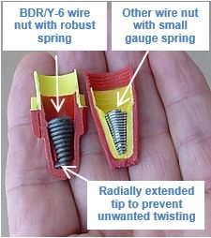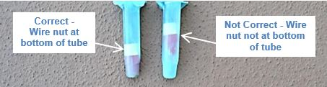A twist-on connector (a.k.a. wire nut) for making a UL-listed mechanical connection.  Once the mechanical connection is made, it shall be inserted into a gel-filled tube and the wire nut shall lock in place when it reaches the bottom   
  of the tube. See photo for correct location of the wire nut.    
  Once the wire nut bottoms out in the tube, it can’t work its way out while the installer is moving the wires, closing the lid of the tube, and stowing the connection in the valve box or next to a Valve-in-Head sprinkler.
* The conical wire spring of the wire nut must be very robust, so that it expands and contracts when temperature changes and always compresses the wires together.
* The conical spring shall have a tip that extends radially so that it is imbedded in the plastic insulation to prevent the spring from spinning while tightening and loosening the wire nut. See photo.
* The lid of the tube shall then be closed such that it applies pressure on the insulation of the wires and creates strain relief.

**3M Model DBR/Y-6 (Paige Electric 270672.) No equal.**

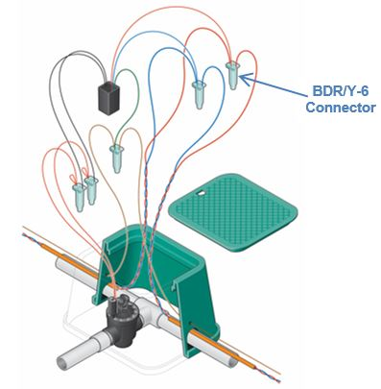

*Installation Tips:*

|  |  |
| --- | --- |
| Step 1 – Strip ¾” of insulation off solid wires.  For stranded wires, strip off 1-1/4” of insulation. |  |
| Step 2 – For solid wires, pinch the tips of the wires together.  For solid and stranded wire combinations, twist the stranded wire onto the solid one. Trim the excess strands of the stranded wires to ¾”  Twist-on the wire nut clockwise until the insulation twists 1 or 2 turns |  |
| Refer to this photo for the terminology of the connector tube |  |
| Step 3 - Line-up the wings of the wire nut with the channels of the tube.  Slide the wires and the wire nut into the tube until they bottom-out. You should feel the wire nut locking in place.  If the wires being spliced are too thin, it is difficult to push them (and the wire nut) into the grease-filled tube.  Use a “thin non-conductive object” to push the wire nut (and wires) into the tube. |  |
| Step 4 – Position the wires in one of the three wire guides and close the lid until it snaps shut. If the wires are skinny, it is better to put multiple wires into one wire guide so that strain relief is maximized. |  |