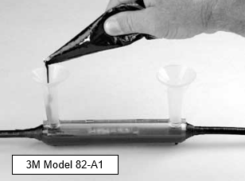**Connectors for power wires and cables carrying 120 or 240VAC** – All splices made to the electrical wires carrying 120VAC or 240VAC to-and-from irrigation controllers shall use one of the following types of connectors:

* 3M Model DBR/Y-6 for single conductor direct burial wires of sizes up to 10AWG.
* 3M 82-A series connector kits for wire and cable sizes up to 1/0AWG. Use the appropriate connector based on the outside diameter of the wires or cables.   
    
  The inner conductors of cables are to be joined using butt connectors or copper alloy split bolts. Bare metal connections shall be insulated using 3M #23 rubber tape to prevent the connections from touching each other. The inner conductors and the outer jacket of the cable shall be inside the connector tube and covered with waterproof resin (see photo “3M Model 82-A1”.)

All wires and splices shall be installed in a valve box. These wires are to be extended a minimum of 24” above ground level, for ease of making splices and for future access.

**Paige Electric Co., LP specification number P7364D for DBR/Y-6, Paige Electric part number 270672. No equal.**

**Paige Electric Co., LP specification number 82-A Series. Paige Electric part numbers: 270329 for 82-A, 270340 for 82-A1, and 270330 for 82-A2. No equal.**

**Paige Electric Co., LP specification number “Tapes” for the 3M #23 Rubber Tape, Paige Electric part number 270001. No equal.**

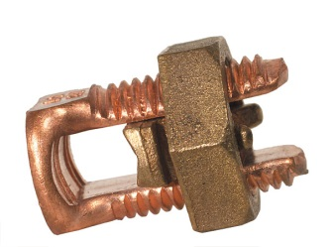**Paige Electric Co., LP specification number “Wire Connectors” for the Split Bolts, Paige Electric part numbers as follows. No equal.**

|  |  |  |
| --- | --- | --- |
| **Paige Part No.** | **Wire Size (AWG)** | |
| 181994 | 8 & 10 | |
| 181999 | 6 | |
| 181998 | 4 | |
| 181997 | 2 | |
| 181993 | 1/0 | |
| 181992 | | 2/0 |