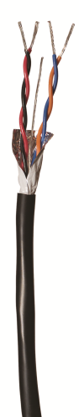**WEATHER STATION AND SENSOR CABLE**

**Shielded Cables for Weather Stations and Sensors** – The cable shall be 18AWG/2-pair. The construction shall include stranded tin coated copper conductors, an aluminum shield to prevent interference due to electro-magnetic noise, a 20AWG tinned copper drain wire for grounding the cable, and an overall PE jacket. One pair of wires is usually sufficient for the installation. In such cases, the second pair shall be used as a spare. The cable shall be listed for direct burial.   
**Paige Electric Co., LP specification number P7171D, or approved equal.**

